
Work Instruction for Creating Automation Change Requests

Viatris
Work Instruction for Creating Automation Change Requests

Contents
Contents 2
1. Introduction 2
1.1. Purpose 2
1.2. Scope of this Report 3
1.3. Audience 3
2. Approach and Methodology 3
2.1. Approach 3
2.1.1. Create a Request for CPU Resource Increase 3
2.1.2. Create a Request for RAM Resource Increase 7
2.1.3. Create a Request for Dell/Cisco Standalone Rack Server Firmware Upgrade 11
2.1.4. Create a request for Linux OS In-Place Upgrade 13
2.1.5. Create a request for Filesystem Add / Extend for virtual servers 15
3. Roles and Responsibilities 18
4. Escalation Matrix 18
6. Revision History 18

1. Introduction

1.1. Purpose
This document provides the steps to create Automation Change Requests.

1.2. Scope of this Report
The scope of this document is to describe how to create Automation Change Requests.

1.3. Audience
GIDC UNIX Group

2. Approach and Methodology

Approach

2.1.1. Create a Request for CPU Resource Increase
- Login to Smartstop online portal.
- Search for Linux CPU and RAM increase Catalog Item
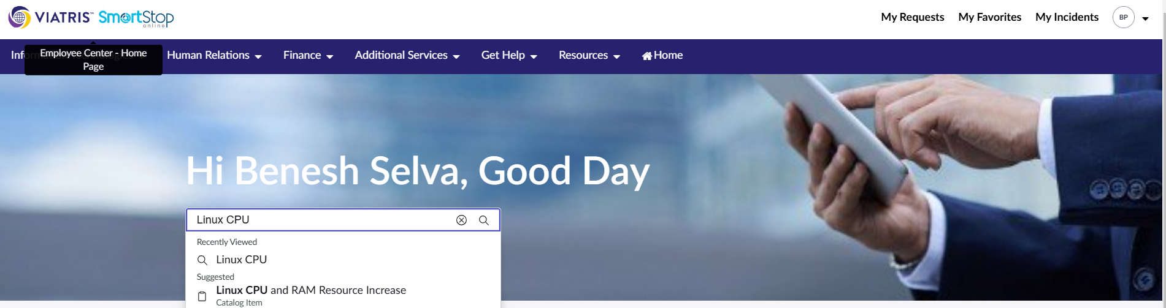
- This will open the following window
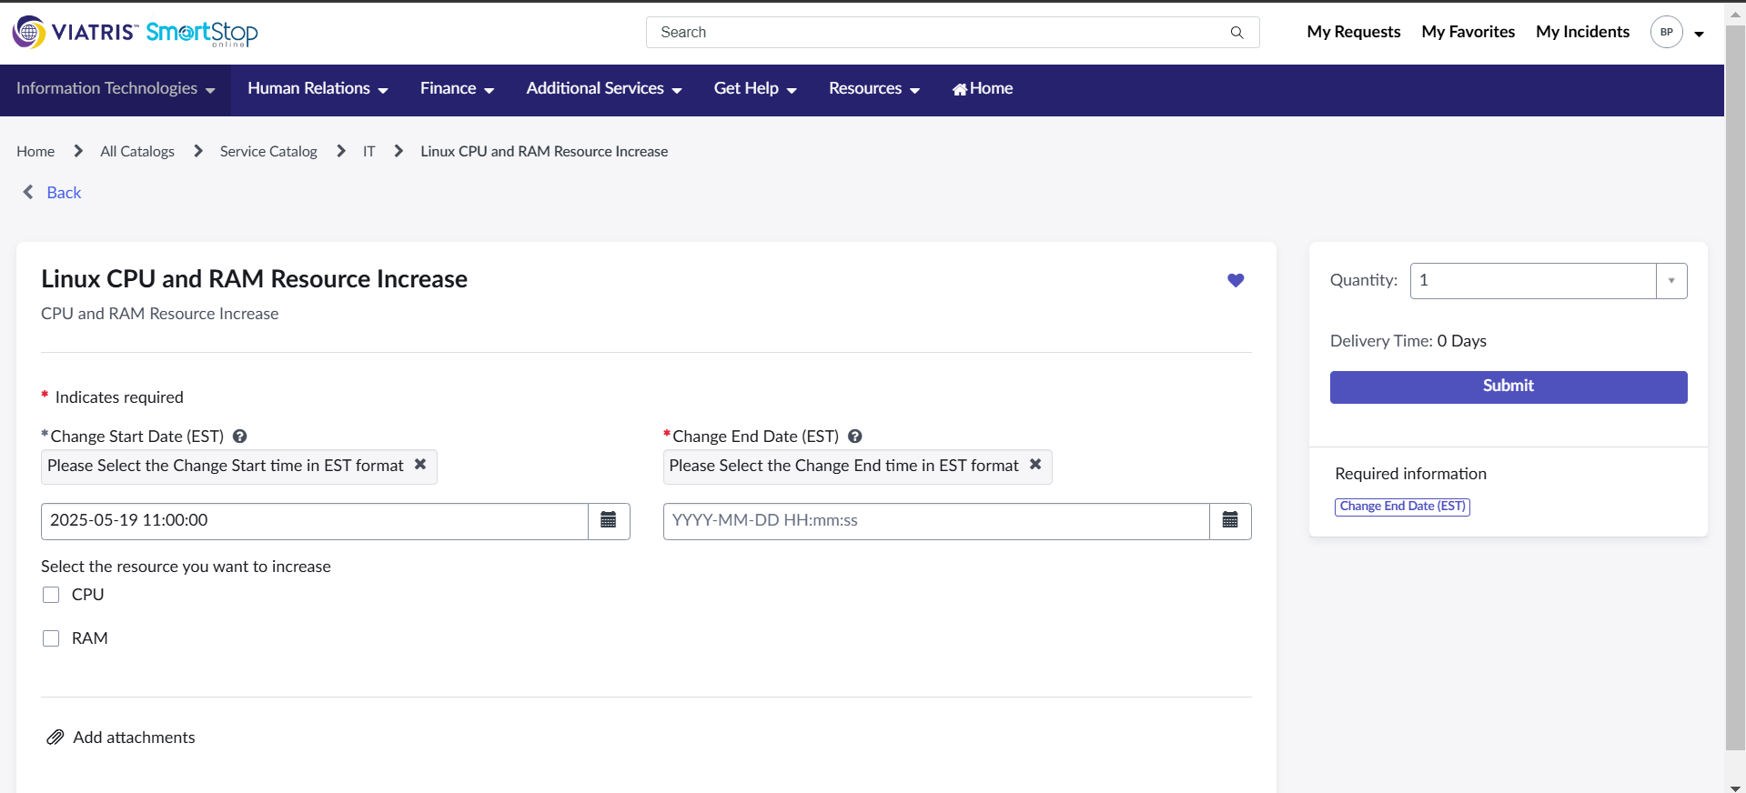
- Select the Start Date and End Date and click on CPU option
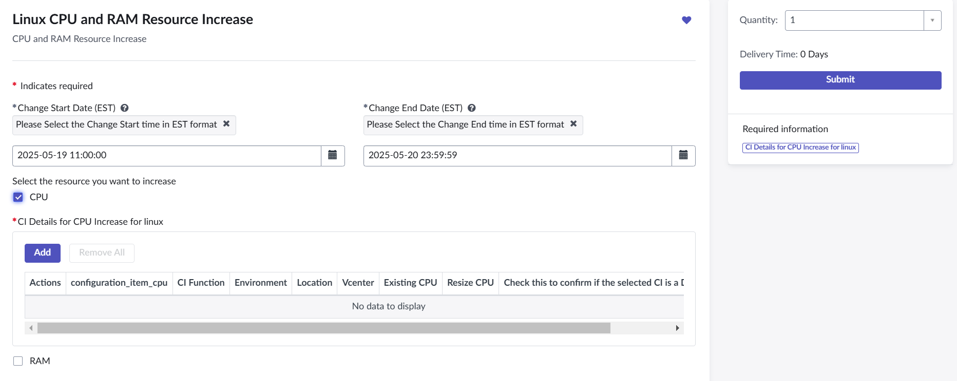

- Click on Add in the CI Details for CPU Increase Field.
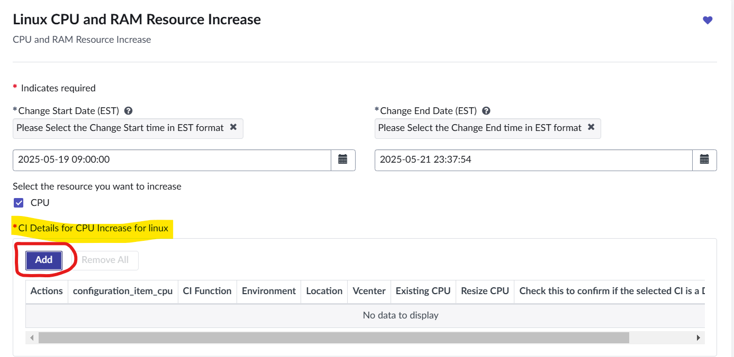
- Feed the required details in the popup window with the configuration Item and Resize CPU and click on add button.
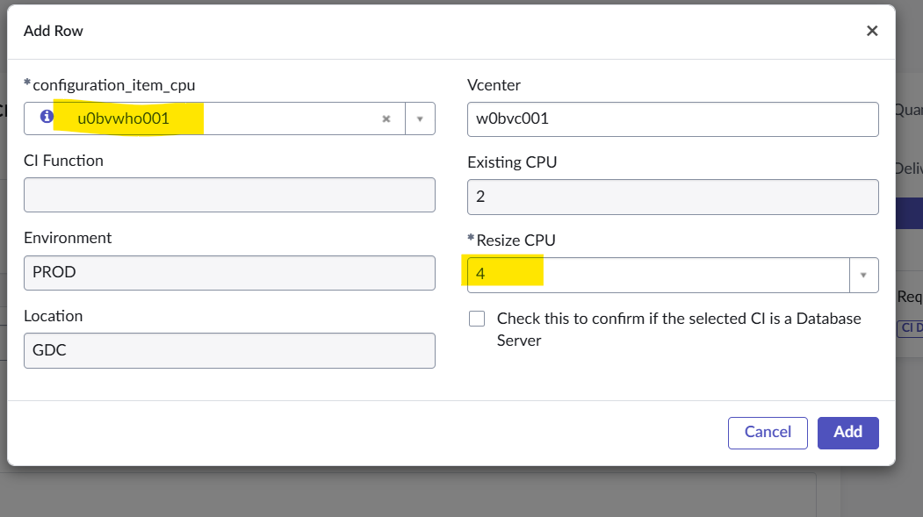
- The provided details will be displayed in the CI Details for CPU Increase for linux field.
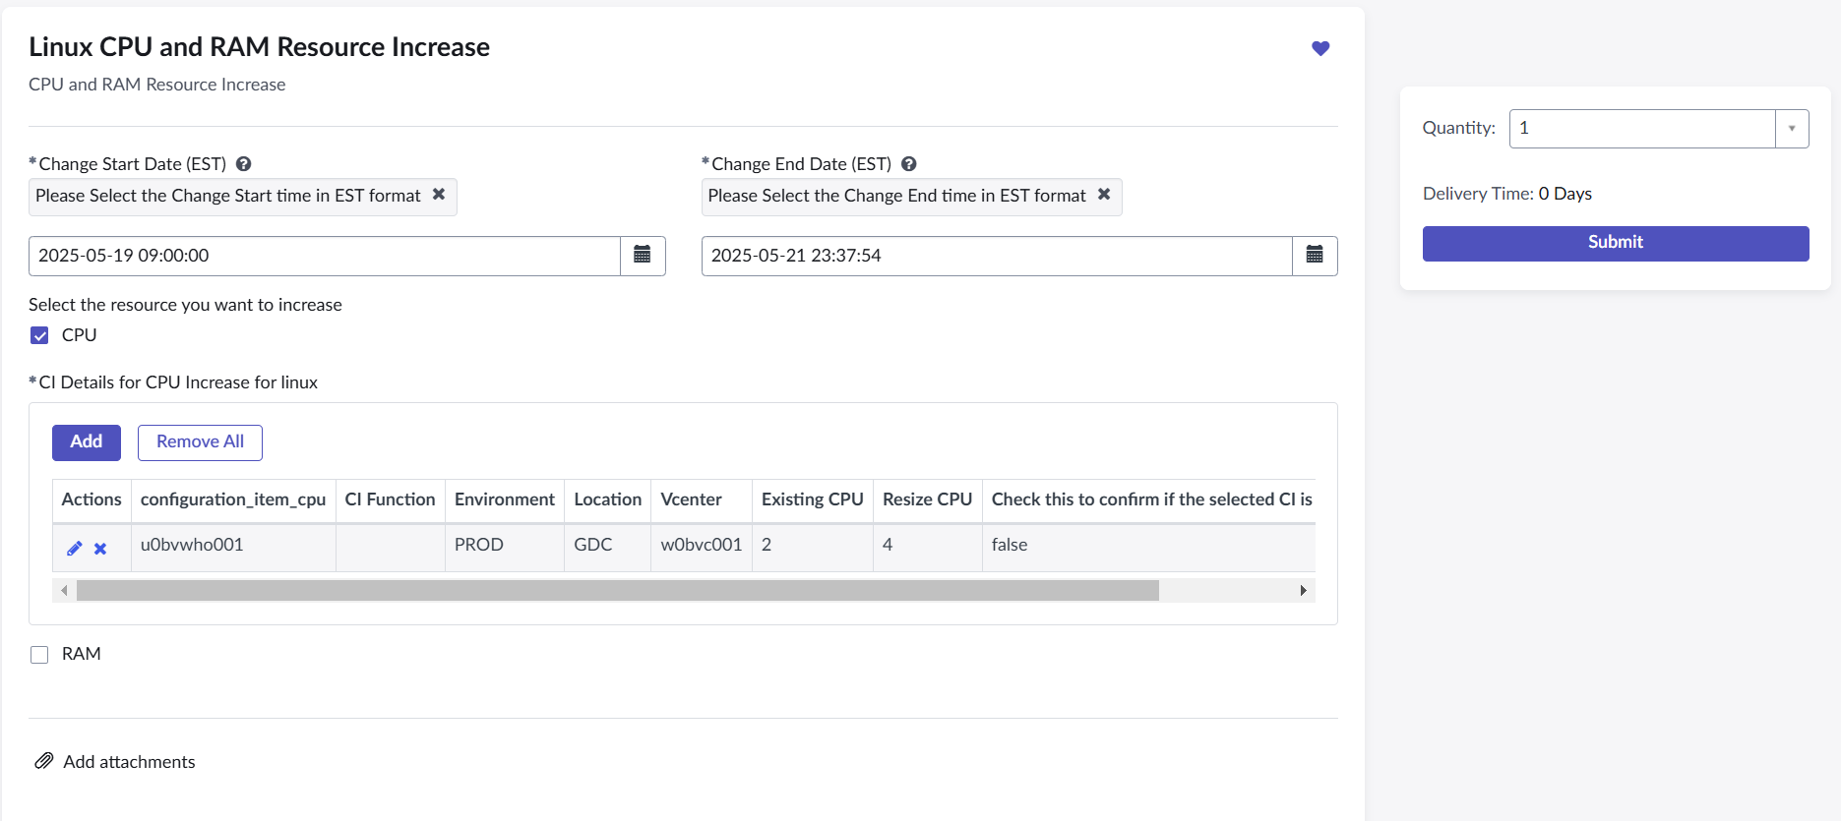
- Then Click on submit button. This will create an RITM and then create a Change Request. The Change Request will be processed for approvals and after the approval phase the automation will increase the CPU according the planned start date and time.
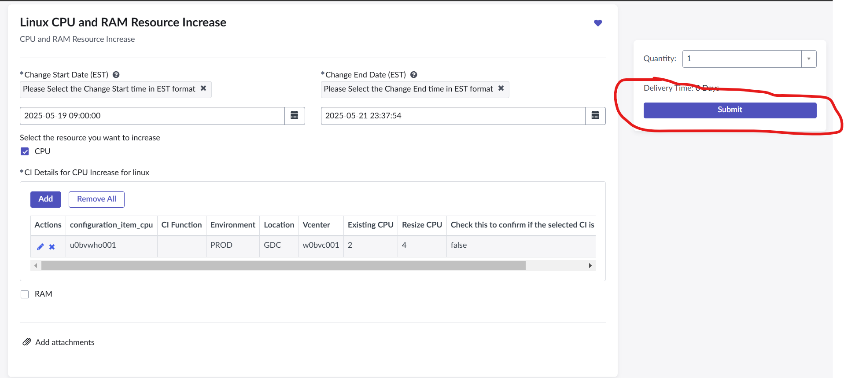

2.1.2. Create a Request for RAM Resource Increase
- Login to Smartstop online portal.
- Search for Linux CPU and RAM increase Catalog Item
- This will open the following window

- Select the Start Date and End Date and click on RAM option
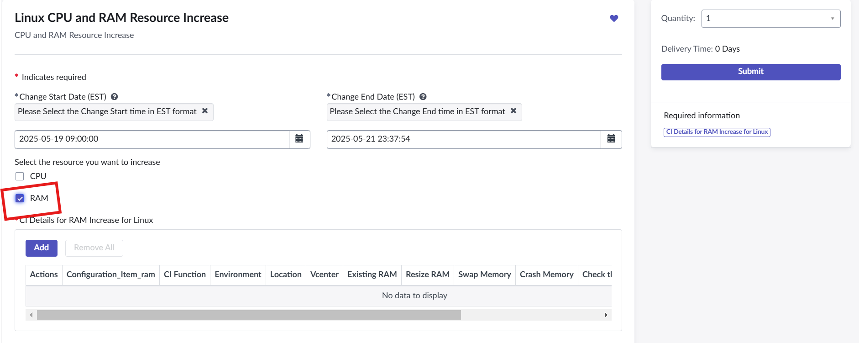
- Click on Add in the CI Details for RAM Increase for Linux Field.
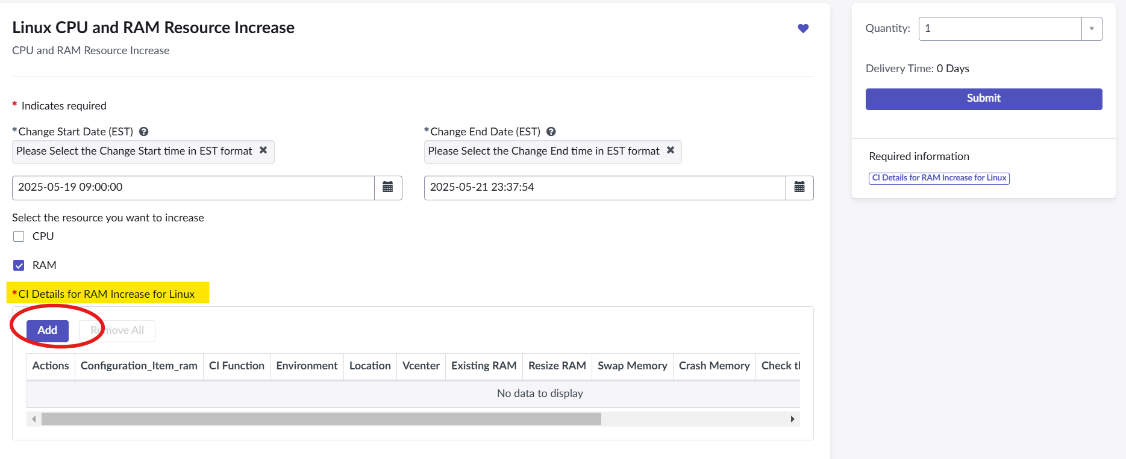
- Feed the required details in the popup window with the configuration Item, Resize RAM, Swap Memory and Crash memory field and click on add button.
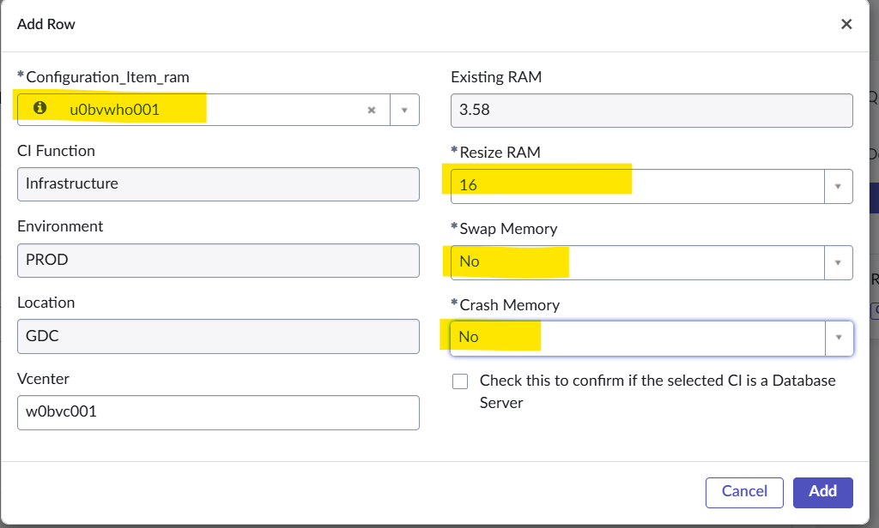
- The provided details will be displayed in the CI Details for CPU Increase for linux field.
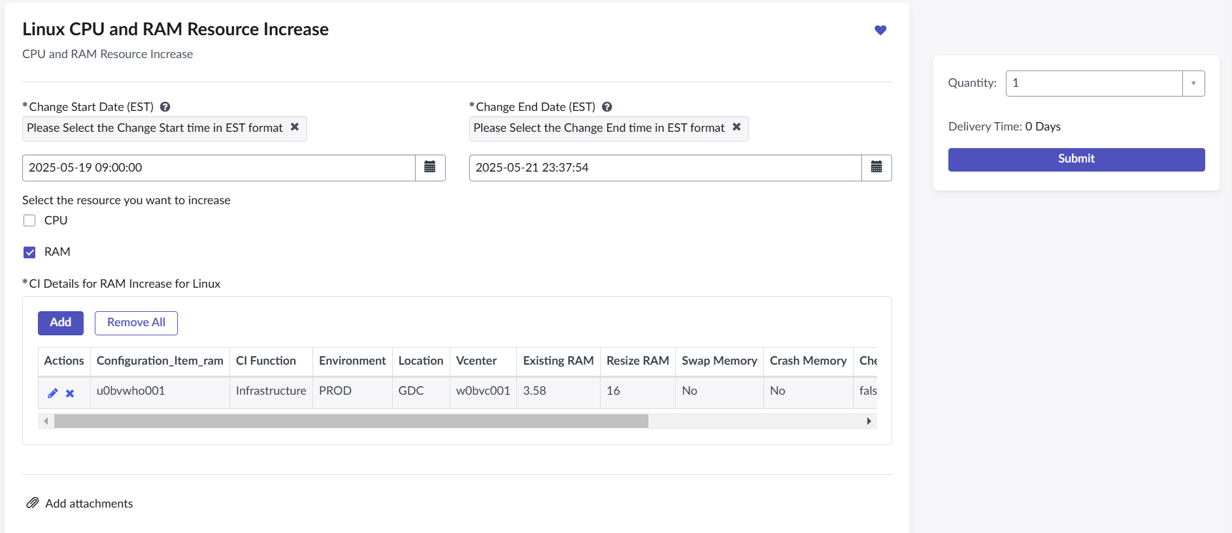

- Then Click on submit button. This will create an RITM and then create a Change Request. The Change Request will be processed for approvals and after the approval phase the automation will increase the RAM according to the planned start date and time.
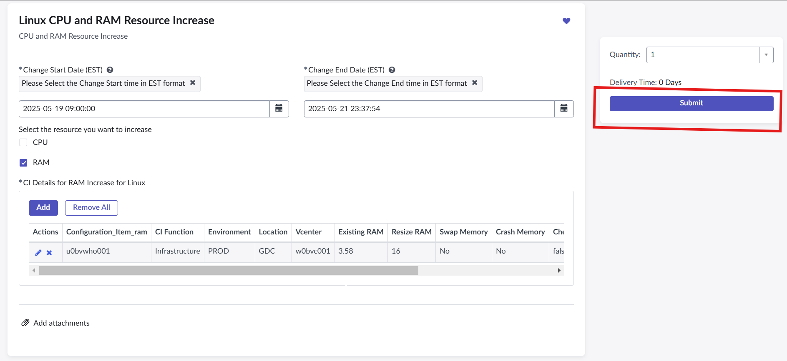

2.1.3. Create a Request for Dell/Cisco Standalone Rack Server Firmware Upgrade
- Login to Smartstop online portal.
- Search for Dell/Cisco Standalone Rack Server Firmware Upgrade Catalog Item.
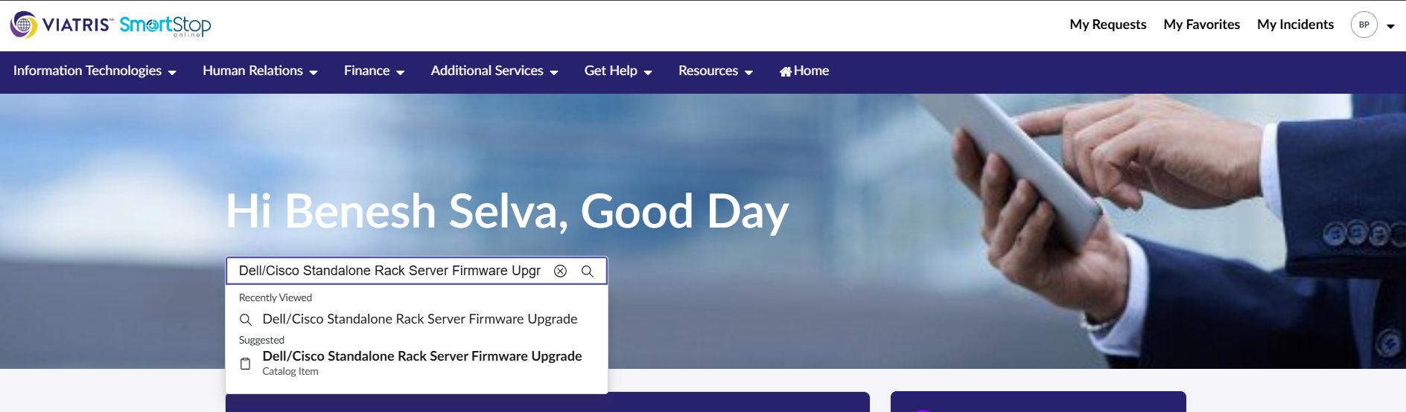
- This will open the following window
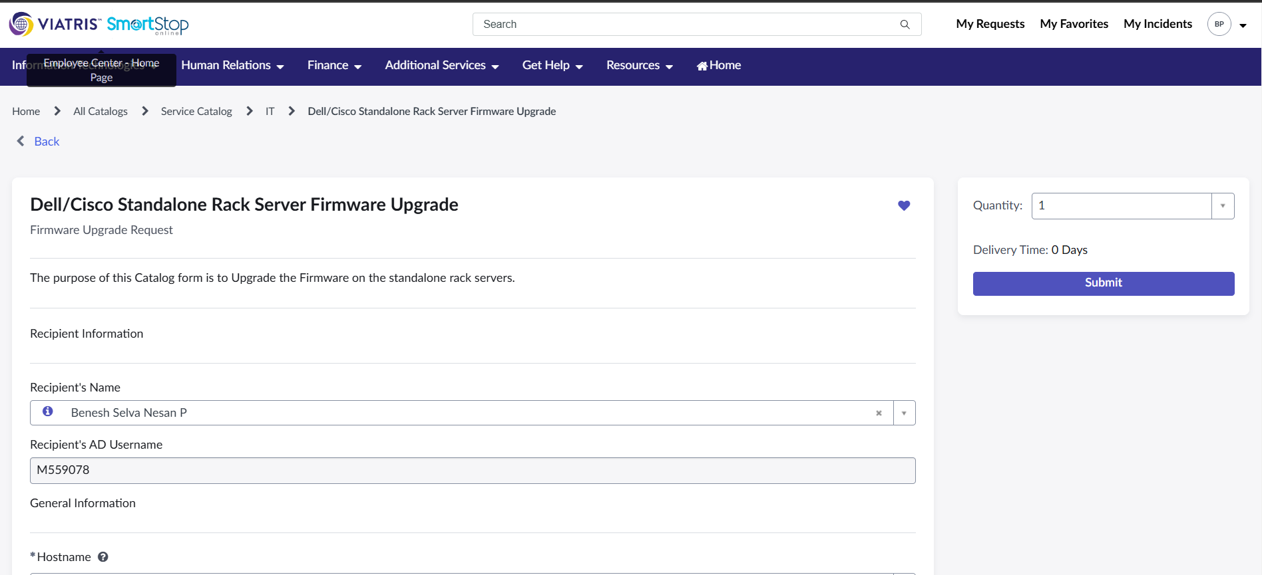
- Add the required fields highlighted in the below screenshot
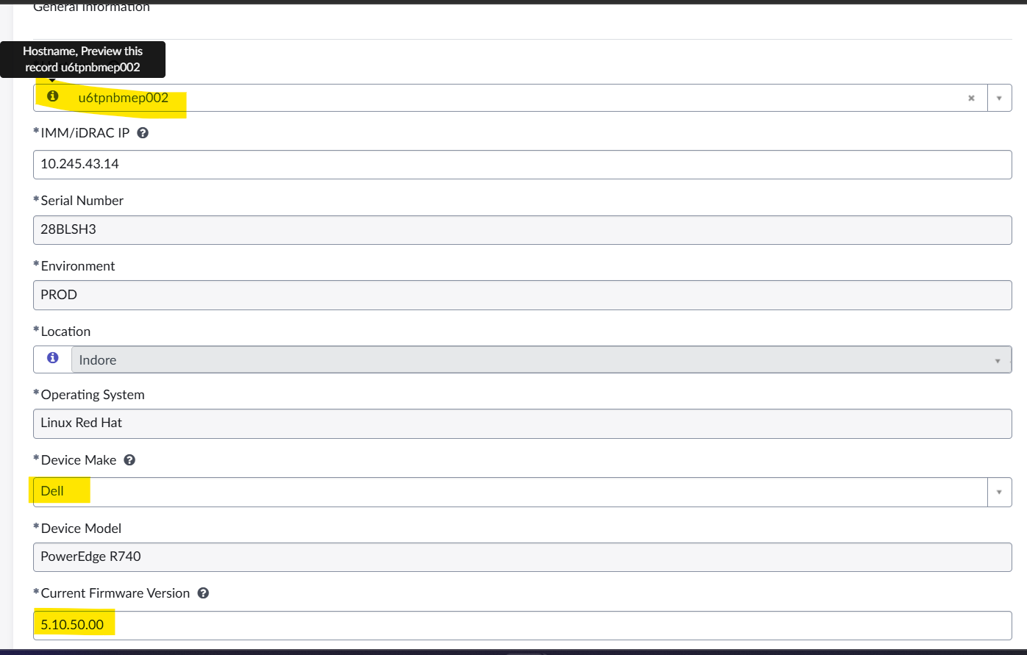

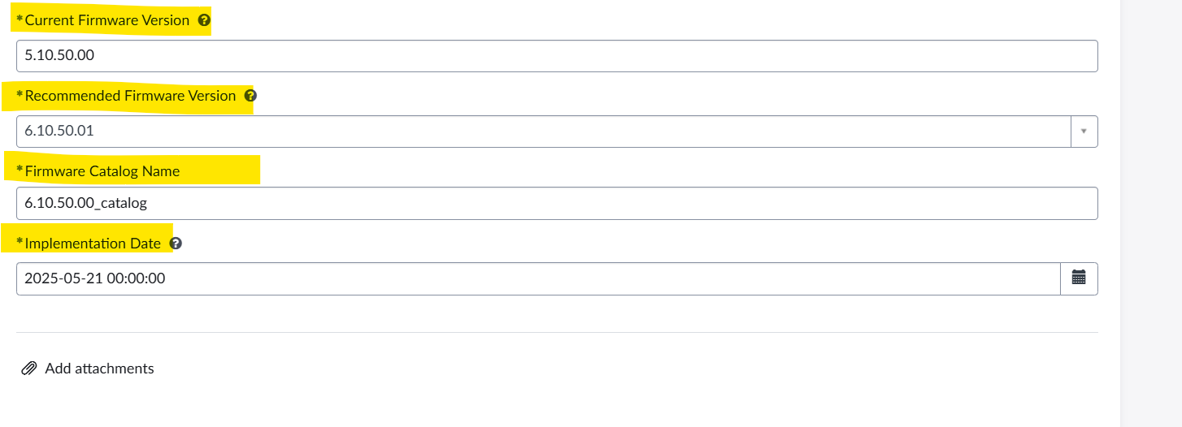
- Then Click on submit button. This will create an RITM and then create a Change Request. The Change Request will be processed for approvals and after the approval phase the automation will create CTASK to stop the services as per the planned start date and time. Once the application services stopped it will create a CTASK to comment the NFS entries in /etc/fstab filesystem. Once the CTASK closed then it will trigger a Backup task and after the successful completion of Backup task it will start implementing the change and upgrade the firmware version. After the completion of Firmware upgrade and successful closure of CTASK again it will trigger CTASK to uncomment the NFS volumes and Start Application Services. After the closure of all CTASK’s the CR will automatically route to closure approvals.

2.1.4. Create a request for Linux OS In-Place Upgrade
- Login to Smartstop online portal.
- Search for Linux OS In-Place Upgrade Catalog Item
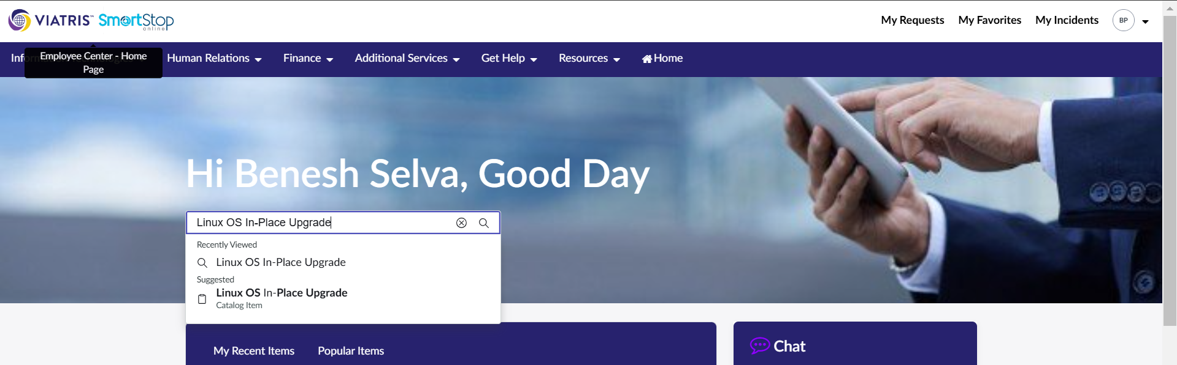
- This will open the following window
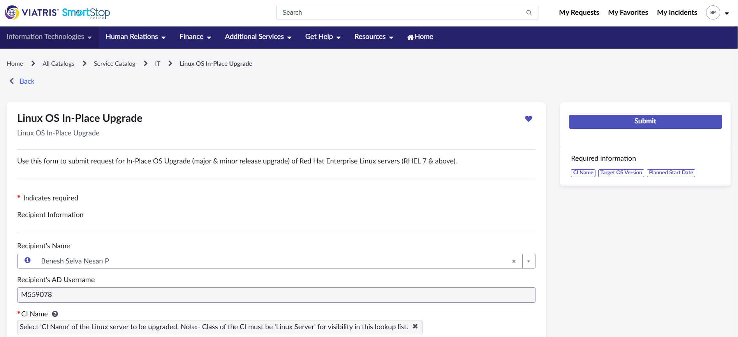
- Add the required fields highlighted in the below screenshot. It will ask the vcenter details for virtual server and for physical server it will not ask the vcenter details
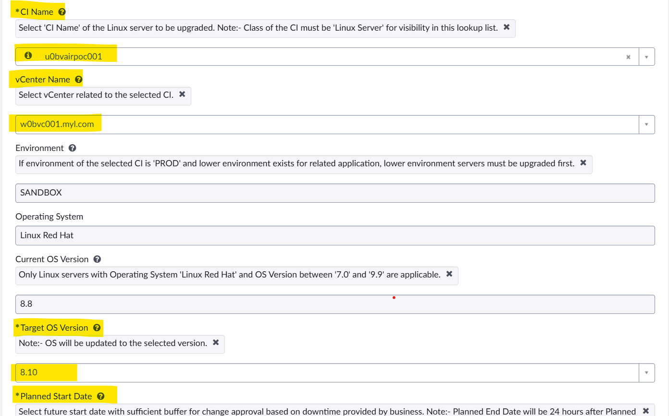
- Then Click on submit button. This will create an RITM and then create a Change Request. The Change Request will be processed for approvals and after the approval phase the automation will create CTASK to stop the services as per the planned start date and time. Once the application services stopped it will create a CTASK to comment the NFS entries in /etc/fstab filesystem. Once the CTASK closed then it will trigger a Backup task and after the successful completion of Backup task it will start implementing the change and upgrade the OS version. After the completion of OS upgrade and successful closure of CTASK again it will trigger CTASK to uncomment the NFS volumes and Start Application Services. After the closure of all CTASK’s the CR will automatically routed to closure approvals.

2.1.5. Create a request for Filesystem Add / Extend for virtual servers
- Login to Smartstop online portal.
- Search for Linux OS In-Place Upgrade Catalog Item
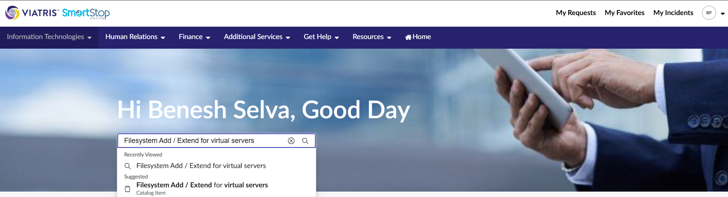
- This will open the following window
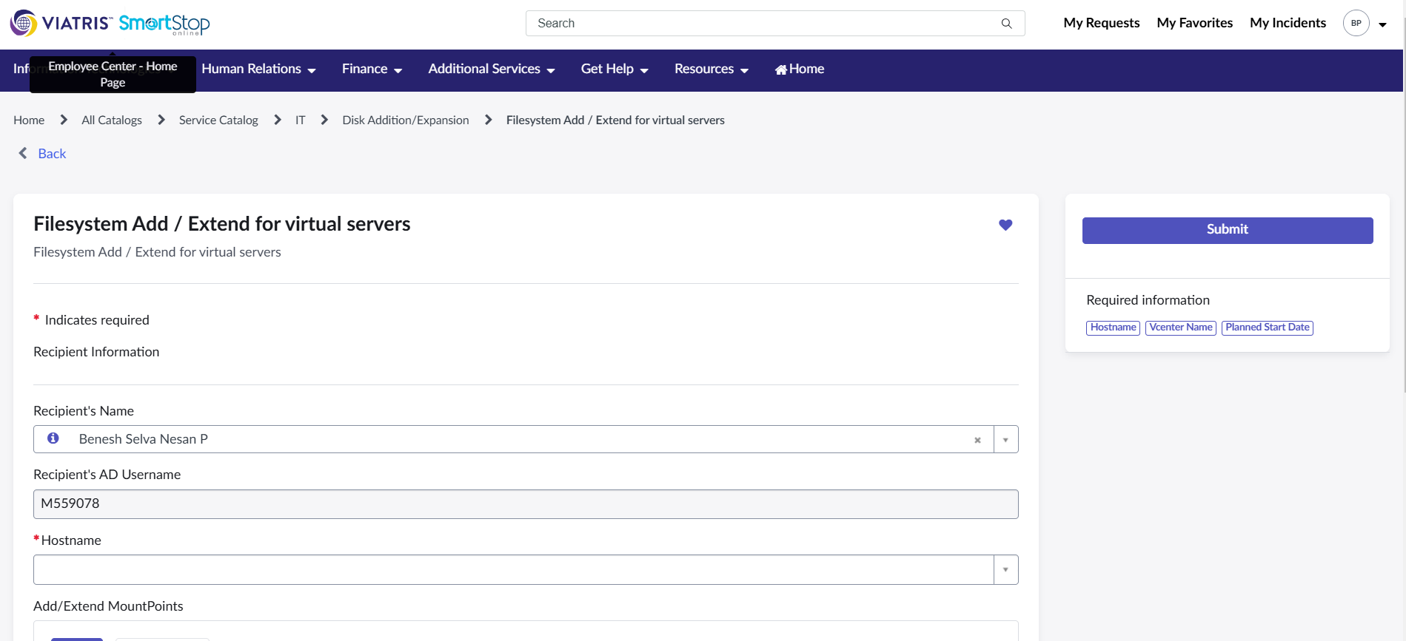
- Give the server name in the hostname field and click on Add button. This will popup a new window in which select the option Add New Mount point for new filesystem creation and give the required fields as per the below screenshot.
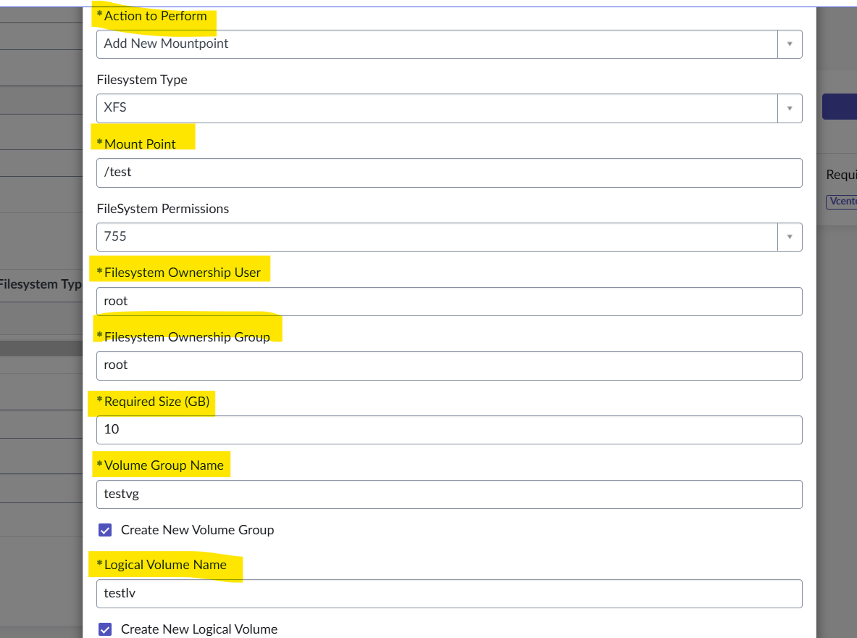
- For Extending File select the option Extend Existing mount point and give the required details as per below screenshot
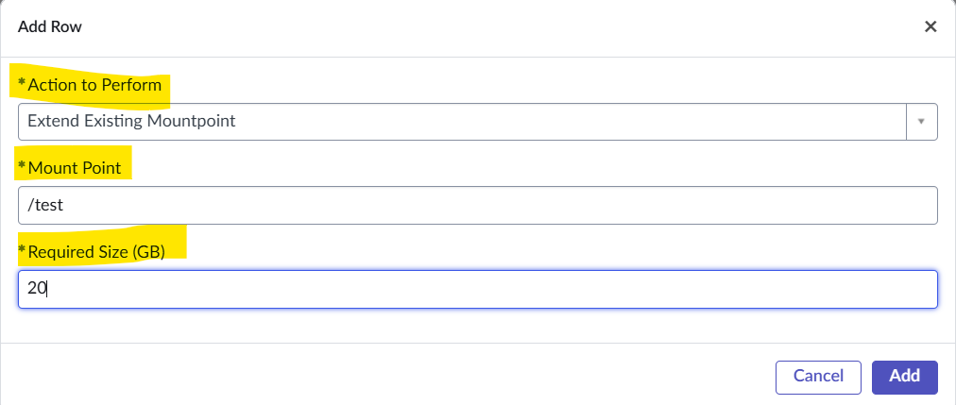
- Give the correct vcenter details and planned start date
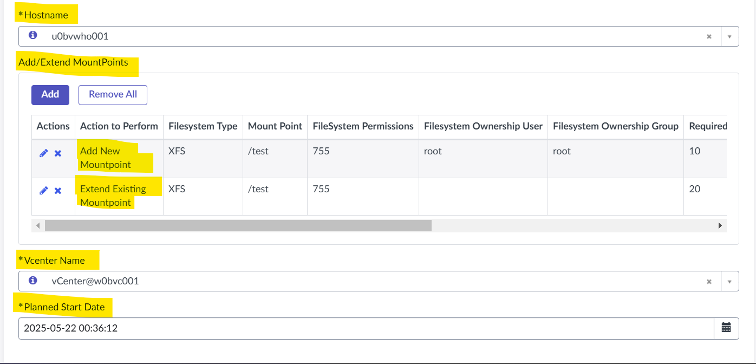
- Then Click on submit button. This will create an RITM and then create a Change Request. The Change Request will be processed for approvals and after the approval phase the automation will create/ Extend the filesystem according to the planned start date and time.

Roles and Responsibilities
Sl. No. | Roles | Responsibilities | Team Member Name
1. | Change Request | Respective Team / Unix Team | GIDC.unix_Run  GIDC.unix_Run@viatris.com
2. | Change Implementation | Respective Team / Unix Team | GIDC.unix_Run  GIDC.unix_Run@viatris.com

Escalation Matrix
Person Responsible | Role | Triggers When
Arun R  Arun.R@viatris.com  +91 9710677240 | Deputy Manager
Ashok Kumar R K  AshokKumar.RK@viatris.com  +91 9967735890 | Senior Manager
Zahir Hussain M ZahirHussain.M@viatris.com  +91 9840689462 | Senior Manager

6. Revision History

Date | Version | Summary of Changes | Author | Approved by
April 28 2025 | V1.0 | Created the Document | Benesh Selva Nesan P | Arun R
April 28 2026 | V1.1 | Validated the Document | Benesh Selva Nesan P | Arun R

